**Implementing CRM for result tracking of a candidate with internal marks**

1. INTRODUCTION

1.1 Overview

Administrator should be able to create all base data including semester ,candidate course and lecturer ,lecturer should have the ability to create internal results, dean ,who is one of the lecturer should have the ability to update Internal Results, Re-evaluation Can be initialized by candidate for all internal Results. Now only dean can update the marks after re-evaluation.

1.2 PURPOSES:

* It helps you in collating all the customer information at one place and helps you in better customer management .
* A want is placing certain personal criteria as to how that need must be fulfilled .
* It is easy way to maintain internal marks.

2 . PROBLEM DEFINITION &DESIGN THINKING

2.1 Empathy map

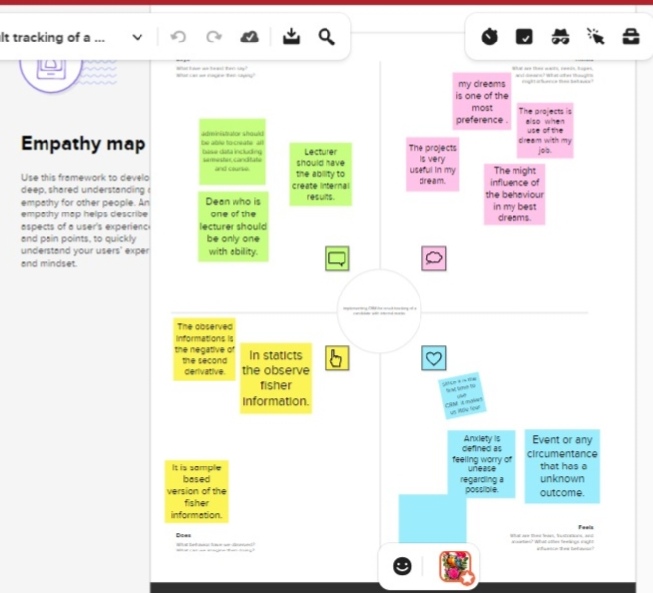

2.2 Ideation&Brainstroming Map

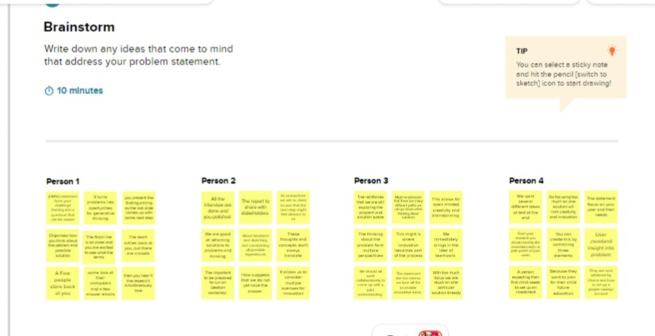

3. RESULT

3.1 Data Model

|  |  |
| --- | --- |
| **OBJECT NAME** | **FILDES IN THE OBJECT** |
| Obj 1 | |  |  | | --- | --- | | Field label | Data Type | | candidate | alphabet | | Course lecturer | alphabet | |
| Obj 2 | |  |  | | --- | --- | | Field label | Data Type | | Internal result | Auto number | | semester | alphabet | |
|  |  |

3.2 Activity and screen shot

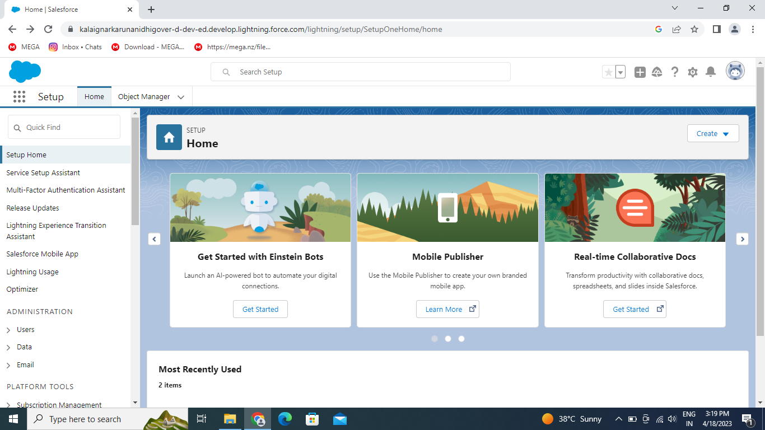

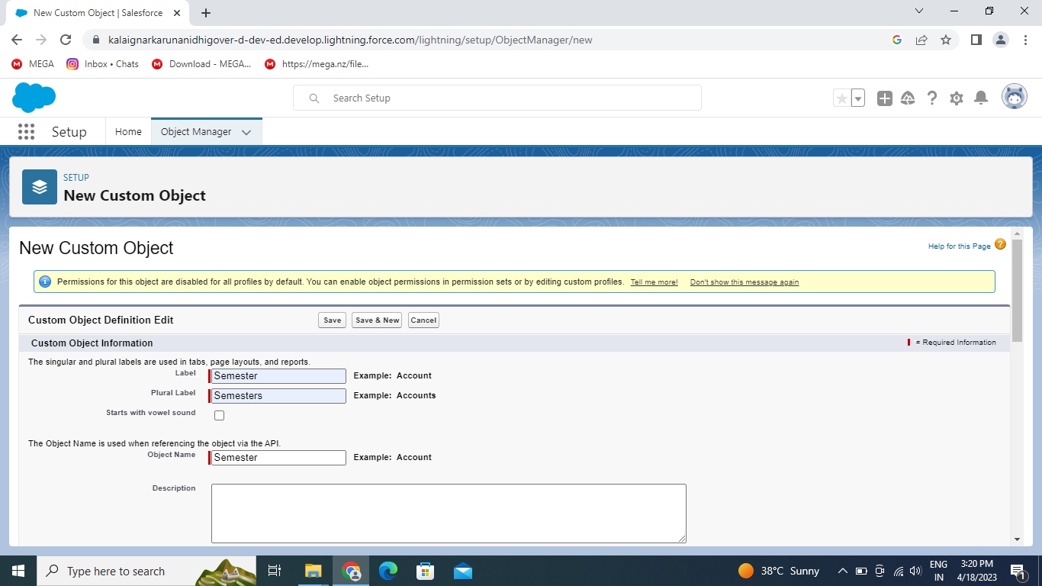

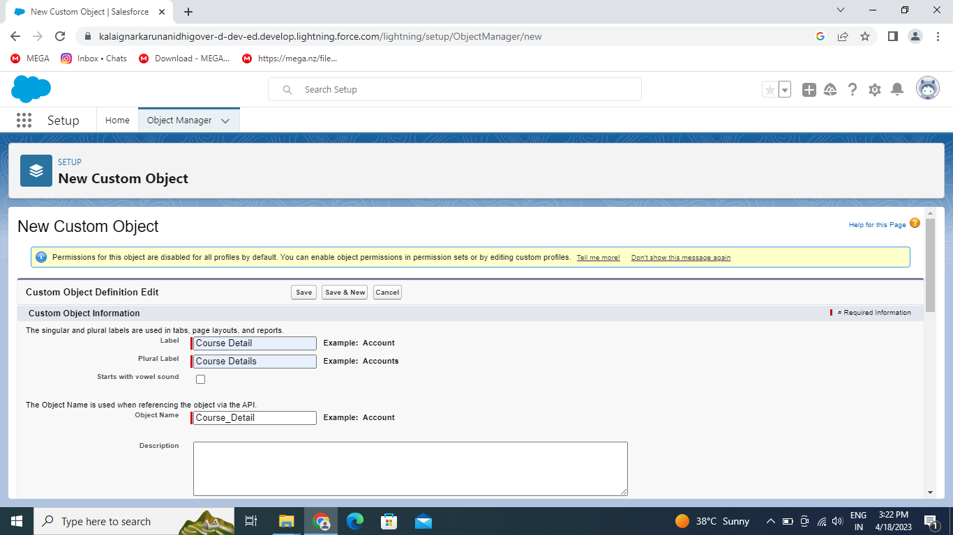

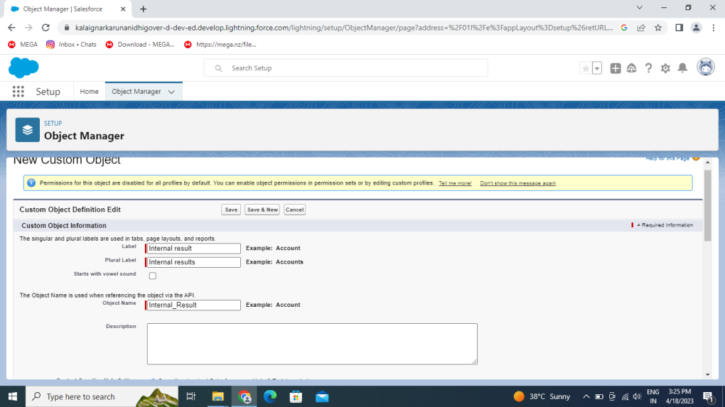

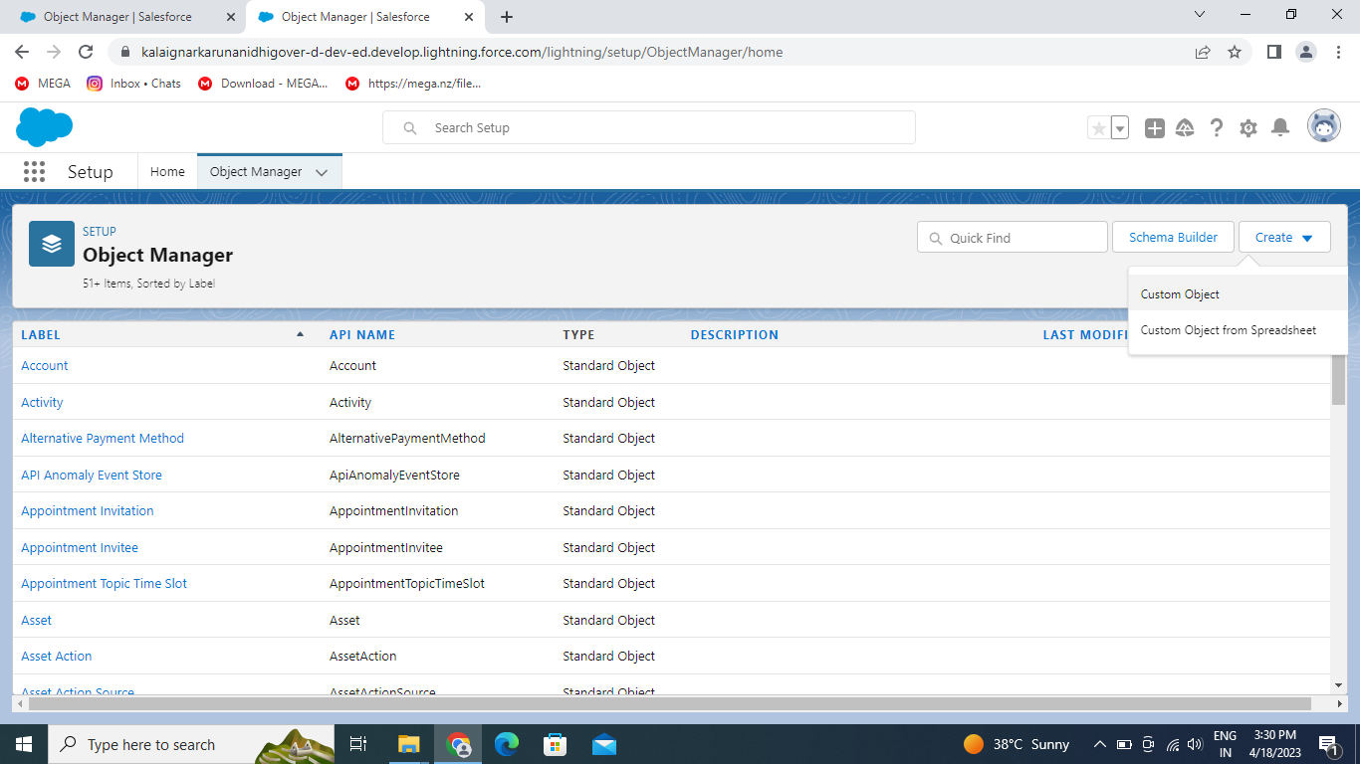

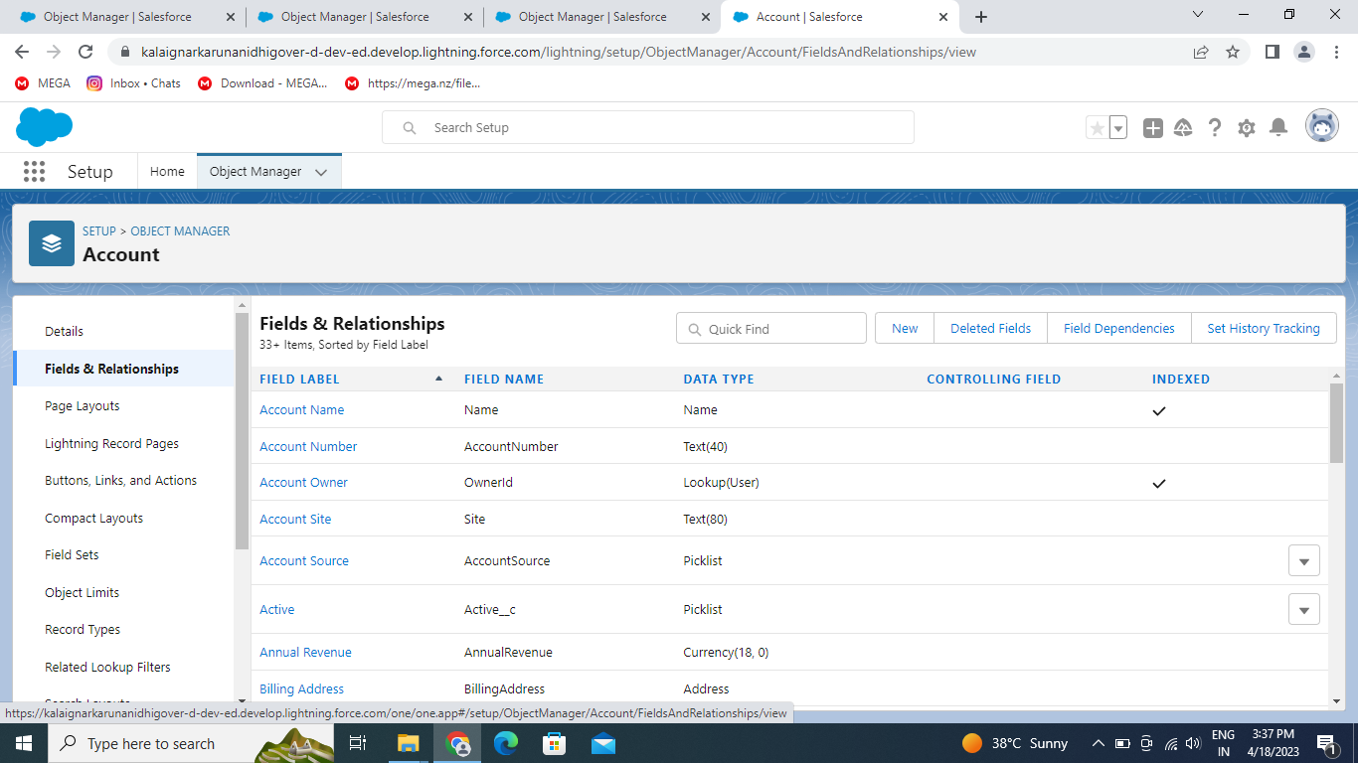

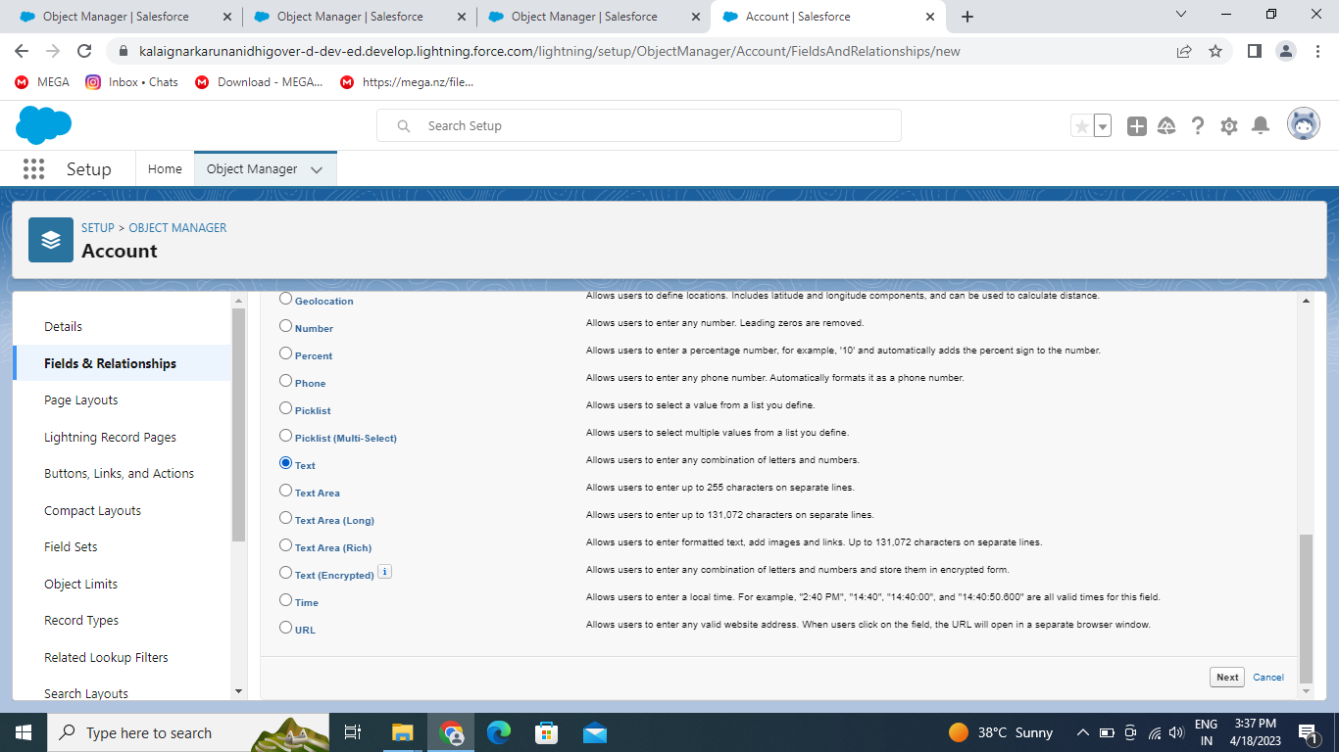

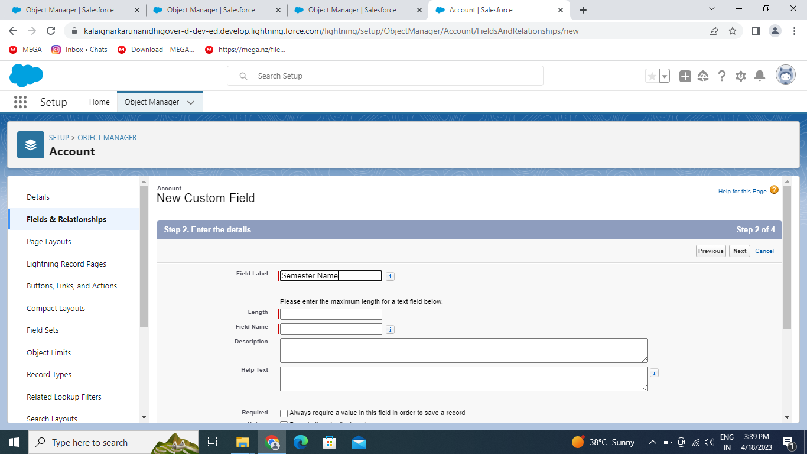

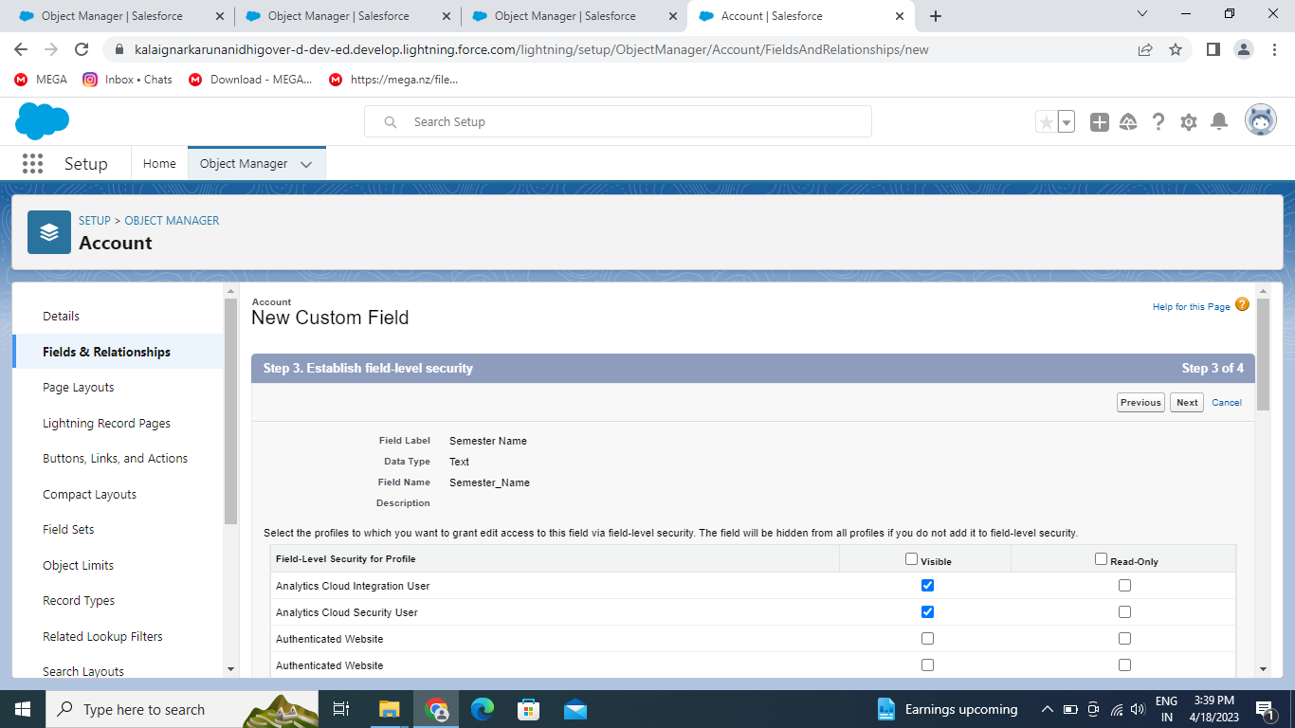

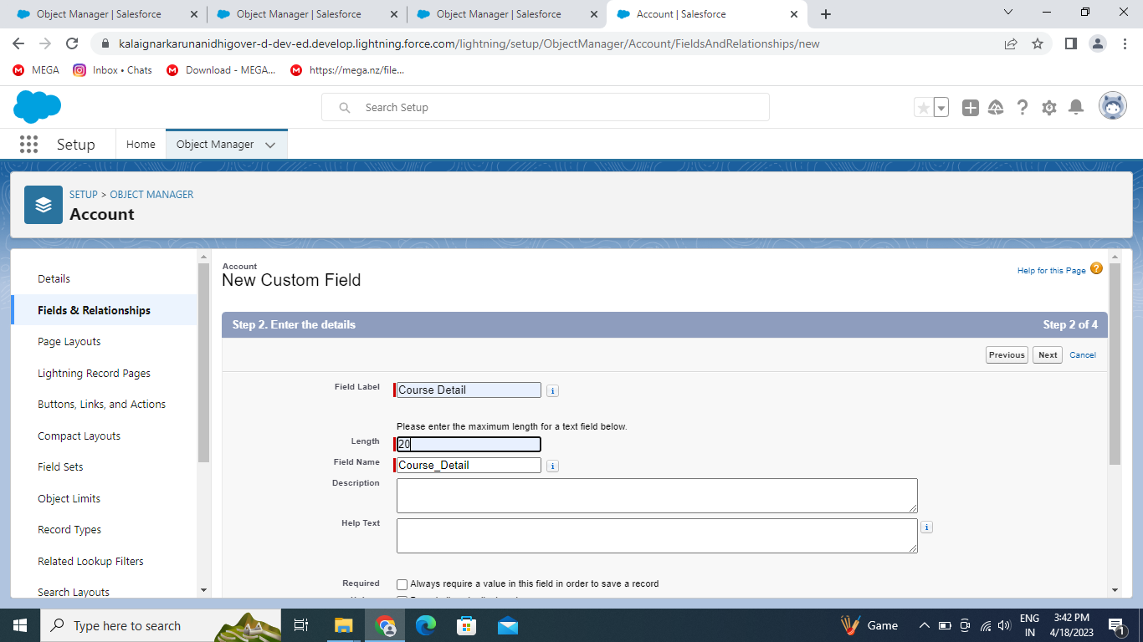

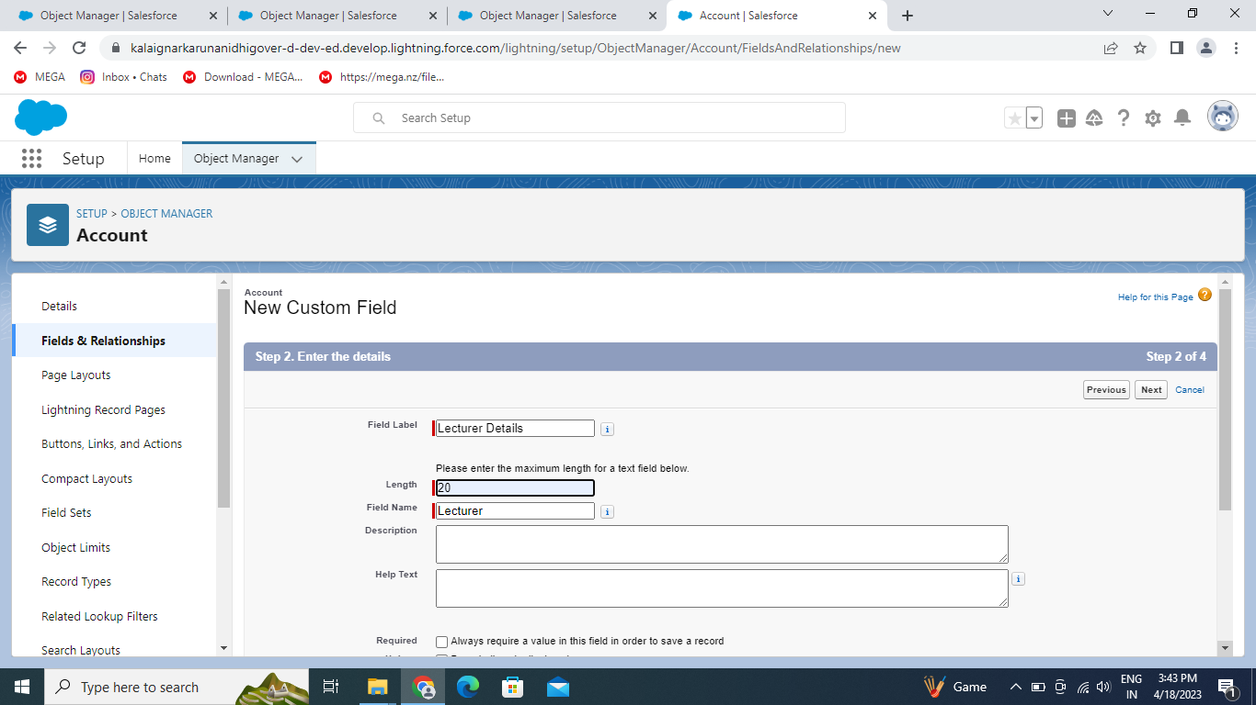

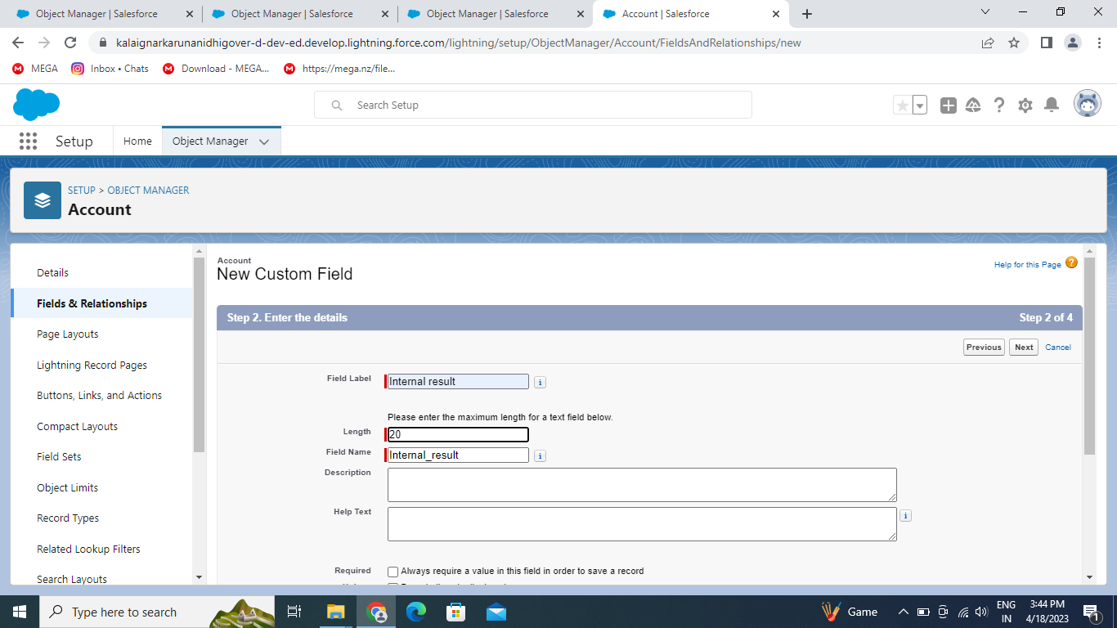

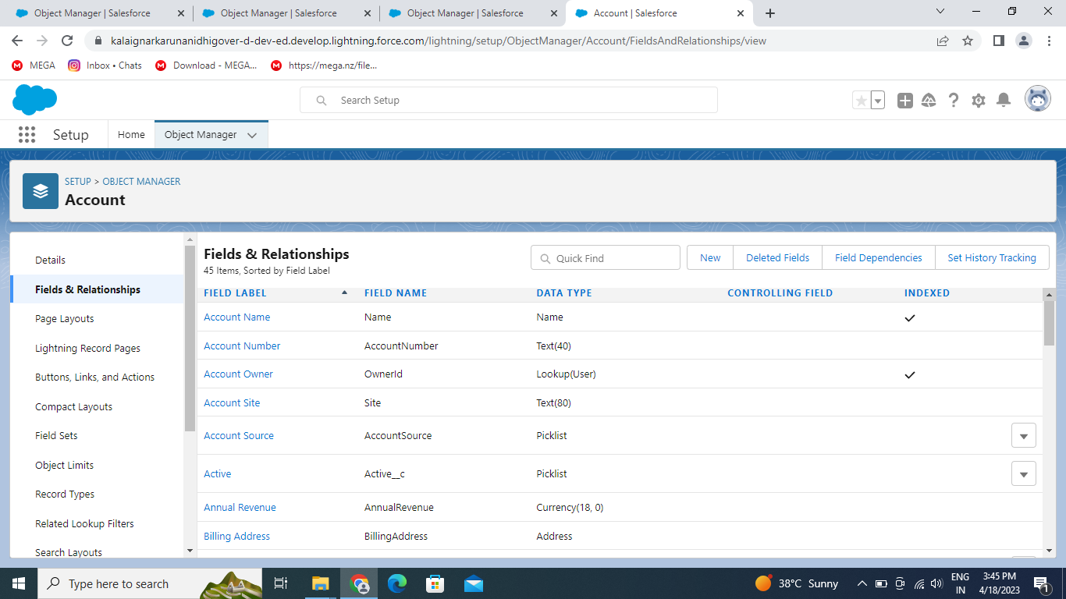

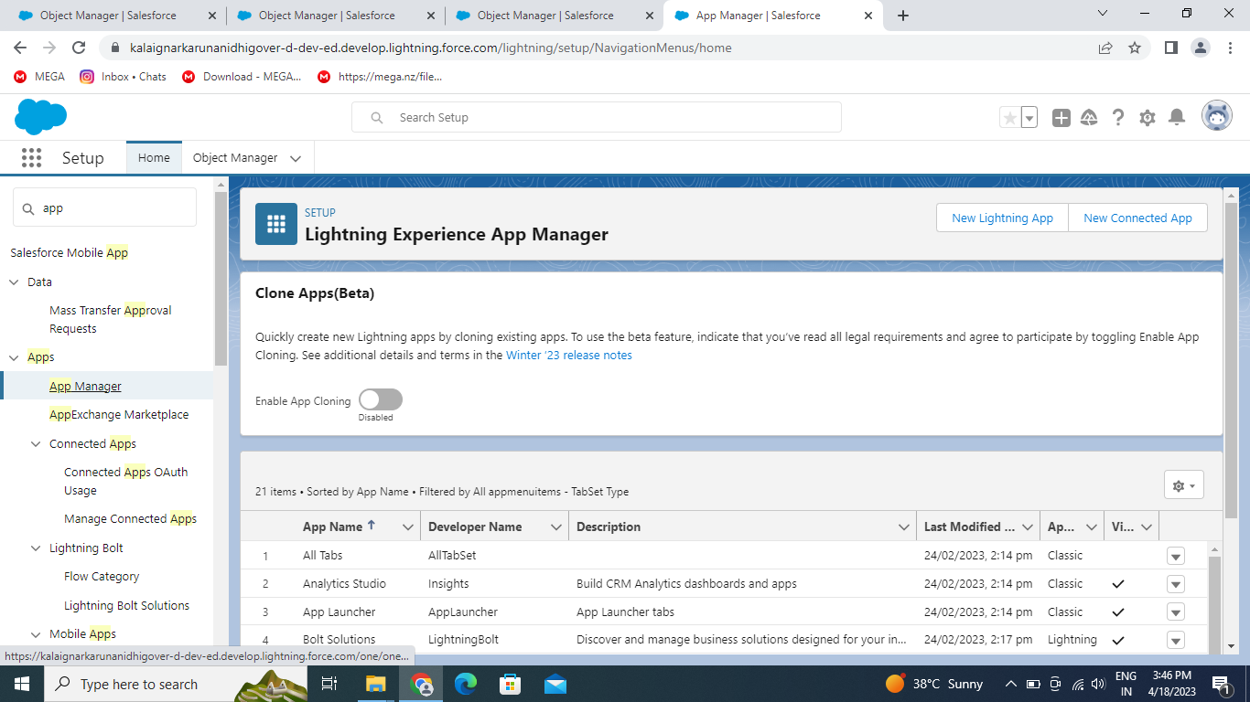

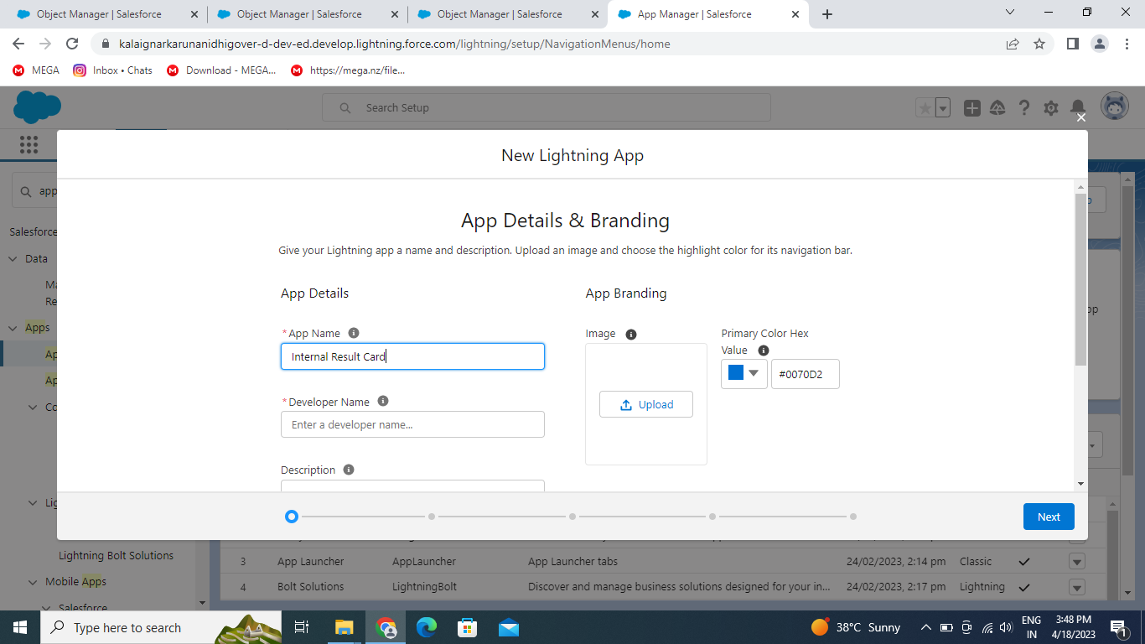

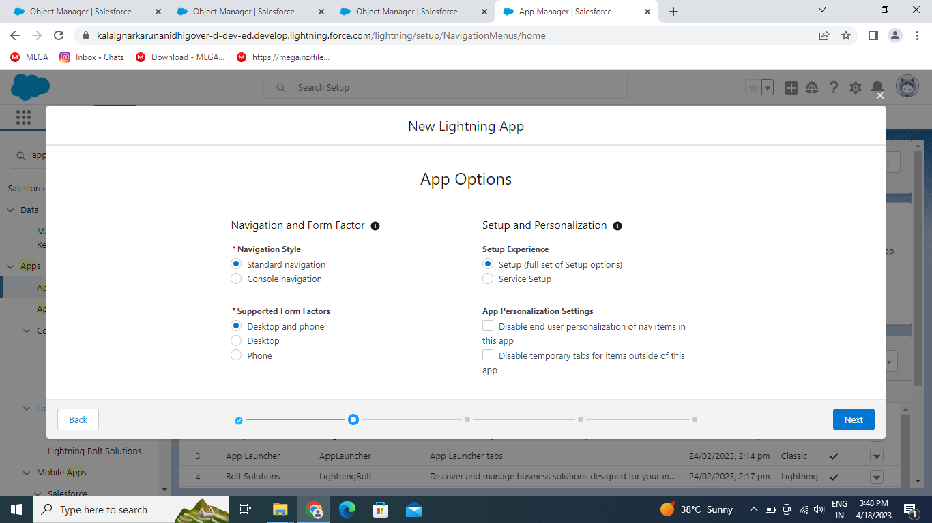

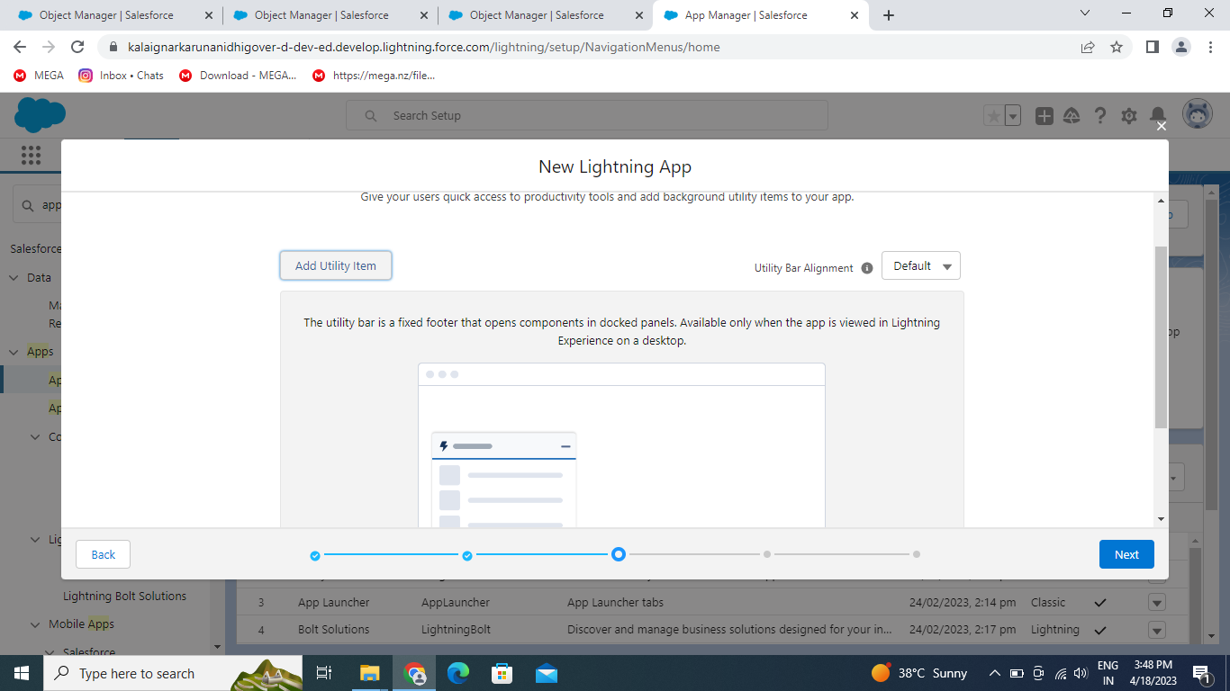

4 . TRAILHEAD PROFILE PUBLIC URL

1. Team Member 1 <https://trailblazer.me/id/hravi56>
2. Team Member 2 <https://trailblazer.me/id/kalas51>
3. Team Member 3 <https://trailblazer.me/id/maham144>
4. Team Member 4 <https://trailblazer.me/id/rocgn>

5 . ADVANTAGES

1. Beneficial for different department or teams of the business.
2. Customers are engaged across multiple channel.
3. Provide streamline operations
4. Improve customer service
5. Data mining
6. Helps in increasing sales
7. CRM made targeting and marketing simple
8. Improve decision making and productivity.

DIS ADVANTAGES

1. Not suitable for every business
2. Experience based procedure in all the stages
3. Can be accessed by third party
4. A costly project
5. Having lot of security concern
6. CRN not fully customized
7. Have poor usability
8. Centralized data is stake

6. APPLICATION

* 1.I want something reliable
* 2.Target marketing
* 3.Increase candidate quality
* 4.cam work easily
* 5.Streamlining internal sales processers

7. CONCLUTION

Student internal mark management system deals with student details. academic related reports college details and course details .It tracks all the details of a student from the day one to the end of his course which can be used for all reporting purpose , tracking of progress in the course, completed semester, upcoming semester details, exam details, project or any other assignment details, and final exam result.

8. FUTURE SCOPE

Scope of education means range of view, outlook , field or opportunity of activity, operation and application of education. Education has a wider meaning and application